

**Project Proposal for 100 Minute Stopwatch with Multiplexing and Persistence of Vision Display**

Diez, Christian Raymond IV J.

Lim, Gian Christian L.

Mendola, Princess Dianne D.

Tan, Jezreel V.

CPE 412N Digital Machine Design

1:30 – 4:30 TTH

**Project Description**

This project is an asynchronous 100-minute stopwatch with a MM:SS display. It will continue to increment every second once activated through the start-stop button and stopped by the same external input. The timer can also be restarted by another external push button called restart. The restart button can only be activated once the timer is not moving to prevent any unwanted accidental restarts. The stopwatch is connected to four 7-segment displays with a common data input lines thus, employing multiplexing and persistence of vision.

**State Table and Diagram**

**State Table**

S = Start-stop Pushbutton ; R = Restart Pushbutton

**Seconds (Ones)**

|  |  |  |  |
| --- | --- | --- | --- |
| **Current state** | **S** | **R** | **Next State** |
| 0000 | 0 | 0 | 0000 |
| 0000 | 1 | 0 | 0001 |
| 0001 | 0 | 0 | 0001 |
| 0001 | 1 | 0 | 0010 |
| 0010 | 0 | 0 | 0010 |
| 0010 | 1 | 0 | 0011 |
| 0011 | 0 | 0 | 0011 |
| 0011 | 1 | 0 | 0100 |
| 0100 | 0 | 0 | 0100 |
| 0100 | 1 | 0 | 0101 |
| 0101 | 0 | 0 | 0101 |
| 0101 | 1 | 0 | 0110 |
| 0110 | 0 | 0 | 0110 |
| 0110 | 1 | 0 | 0111 |
| 0111 | 0 | 0 | 0111 |
| 0111 | 1 | 0 | 1000 |
| 1000 | 0 | 0 | 1000 |
| 1000 | 1 | 0 | 1001 |
| 1001 | 0 | 0 | 1001 |
| 1001 | 1 | 0 | 0000 |
| X | 0 | 1 | 0000 |
| X | 1 | 1 | Continue count |

Go to SECONDS(TENS)

**Seconds (Tens)**

|  |  |  |  |
| --- | --- | --- | --- |
| **Current state** | **S** | **R** | **Next state** |
| 0000 | 0 | 0 | 0000 |
| 0000 | 1 | 0 | 0001 |
| 0001 | 0 | 0 | 0001 |
| 0001 | 1 | 0 | 0010 |
| 0010 | 0 | 0 | 0010 |
| 0010 | 1 | 0 | 0011 |
| 0011 | 0 | 0 | 0011 |
| 0011 | 1 | 0 | 0100 |
| 0100 | 0 | 0 | 0100 |
| 0100 | 1 | 0 | 0101 |
| 0101 | 0 | 0 | 0101 |
| 0101 | 1 | 0 | 0000 |
| x | 0 | 1 | 0000 |
| x | 1 | 1 | Continue count |

Go to MINUTES(ONES)

Go to SECONDS(ONES)

**Minutes (Ones)**

|  |  |  |  |
| --- | --- | --- | --- |
| **Current state** | **S** | **R** | **Next state** |
| 0000 | 0 | 0 | 0000 |
| 0000 | 1 | 0 | 0001 |
| 0001 | 0 | 0 | 0001 |
| 0001 | 1 | 0 | 0010 |
| 0010 | 0 | 0 | 0010 |
| 0010 | 1 | 0 | 0011 |
| 0011 | 0 | 0 | 0011 |
| 0011 | 1 | 0 | 0100 |
| 0100 | 0 | 0 | 0100 |
| 0100 | 1 | 0 | 0101 |
| 0101 | 0 | 0 | 0101 |
| 0101 | 1 | 0 | 0110 |
| 0110 | 0 | 0 | 0110 |
| 0110 | 1 | 0 | 0111 |
| 0111 | 0 | 0 | 0111 |
| 0111 | 1 | 0 | 1000 |
| 1000 | 0 | 0 | 1000 |
| 1000 | 1 | 0 | 1001 |
| 1001 | 0 | 0 | 1001 |
| 1001 | 1 | 0 | 0000 |
| X | 0 | 1 | 0000 |
| X | 1 | 1 | Continue count |

Go to MINUTES(TENS)

Go to SECONDS(ONES)

**Minutes (Tens)**

|  |  |  |  |
| --- | --- | --- | --- |
| **Current state** | **S** | **R** | **Next state** |
| 0000 | 0 | 0 | 0000 |
| 0000 | 1 | 0 | 0001 |
| 0001 | 0 | 0 | 0001 |
| 0001 | 1 | 0 | 0010 |
| 0010 | 0 | 0 | 0010 |
| 0010 | 1 | 0 | 0011 |
| 0011 | 0 | 0 | 0011 |
| 0011 | 1 | 0 | 0100 |
| 0100 | 0 | 0 | 0100 |
| 0100 | 1 | 0 | 0101 |
| 0101 | 0 | 0 | 0101 |
| 0101 | 1 | 0 | 0110 |
| 0110 | 0 | 0 | 0110 |
| 0110 | 1 | 0 | 0111 |
| 0111 | 0 | 0 | 0111 |
| 0111 | 1 | 0 | 1000 |
| 1000 | 0 | 0 | 1000 |
| 1000 | 1 | 0 | 1001 |
| 1001 | 0 | 0 | 1001 |
| 1001 | 1 | 0 | 0000 |
| X | 0 | 1 | 0000 |
| X | 1 | 1 | Continue count |

Go to SECONDS(ONES)

Go to SECONDS(ONES)

**State Diagram**

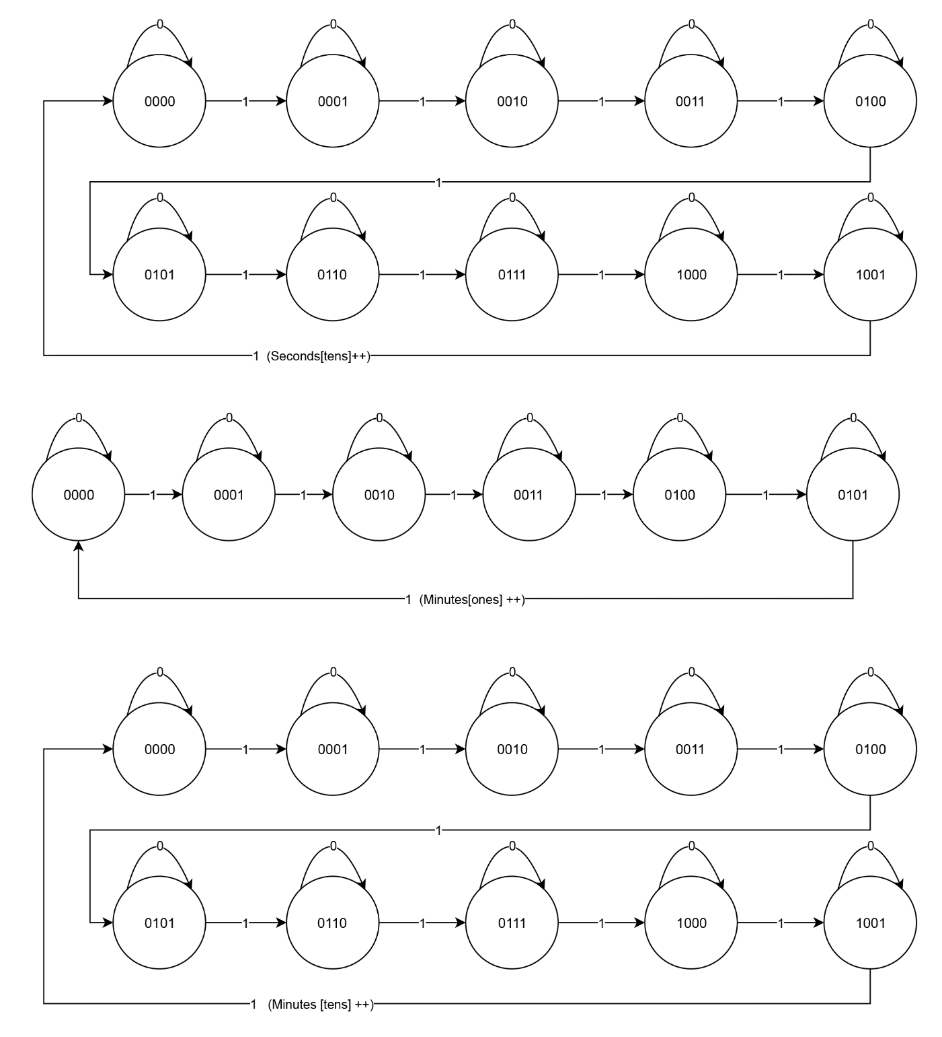

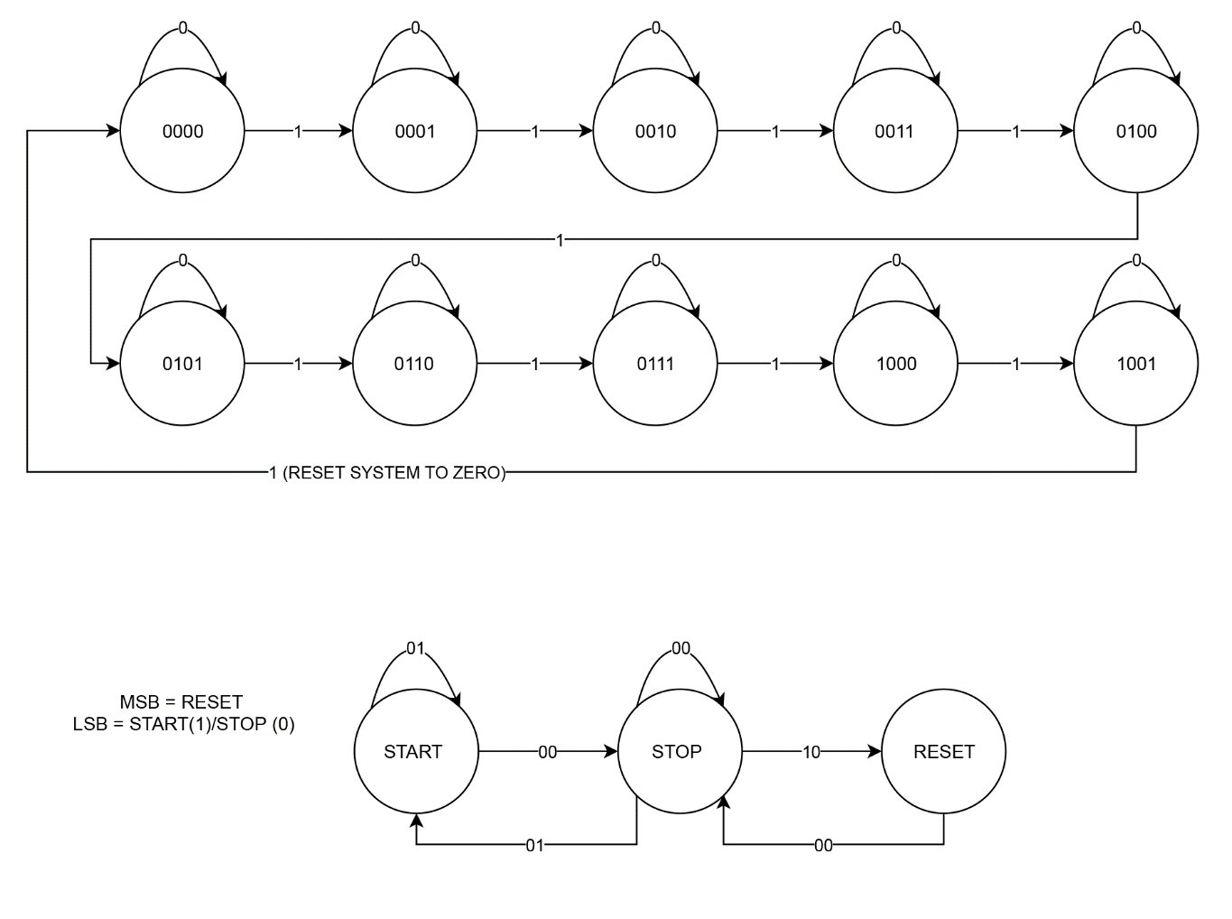

|  |  |  |
| --- | --- | --- |
| **Mux Table** | | |
| **Select Data Inputs** | | **Output** |
| S1 | S0 | Y |
| 0 | 0 | Ones |
| 0 | 1 | Tens |
| 1 | 0 | Ones-Min |
| 1 | 1 | Tens-Min |

|  |  |
| --- | --- |
|  | **Equation (Clocks)** |
| Ones | Clock source (4060) |
| Tens | Qd of Ones |
| Ones-Min | QbQc + R0 |
| Tens-Min | Qd of Ones-Min |

**Logic Functions**

|  |  |  |  |  |
| --- | --- | --- | --- | --- |
| **Decade Counter Table** | | | | |
| **Count** | **Output** | | | |
|  | QD | QC | QB | QA |
| 0 | 0 | 0 | 0 | 0 |
| 1 | 0 | 0 | 0 | 1 |
| 2 | 0 | 0 | 1 | 0 |
| 3 | 0 | 0 | 1 | 1 |
| 4 | 0 | 1 | 0 | 0 |
| 5 | 0 | 1 | 0 | 1 |
| 6 | 0 | 1 | 1 | 0 |
| 7 | 0 | 1 | 1 | 1 |
| 8 | 1 | 0 | 0 | 0 |
| 9 | 1 | 0 | 0 | 1 |

|  |  |
| --- | --- |
| **Operation 1** | Ones Counter++ |
| **Operation 2** | Tens Counter++  Ones Counter = 0 |
| **Operation 3** | Ones Minutes Counter++  Tens Counter = 0 |
| **Operation 4** | Tens Minutes Counter++  Ones Minute Counter = 0 |
| **Operation 5** | Ones = 0  Tens = 0  Ones Minute = 0  Tens Minute = 0 |

|  |  |  |
| --- | --- | --- |
| **Statement** | **Condition** | |
| ***Statements In order*** | **Yes** | **No** |
| Ones Counter < 10? | Execute Operation 1 | Go to next Statement |
| Tens Counter < 6? | Execute Operation 2 | Go to next Statement |
| Ones Minute Counter < 10? | Execute Operation 3 | Go to next Statement |
| Tens Minute Counter < 10? | Execute Operation 4 | Execute Operation 5 |

**Test Input and Output**

|  |  |  |
| --- | --- | --- |
| **Test Inputs** | | **Outputs** |
| **Start-Stop Pushbutton** | **Restart Pushbutton** | **7-Segment Display Counter** |
| 0 | 0 | Stopwatch does not count up. |
| 0 | 1 | All outputs in the stopwatch resets to 0. Display turns 00:00. |
| 1 | 0 | Stopwatch counts up. |
| 1 | 1 | Stopwatch continues counting up ignoring the restart button input. |